H.T No
Regulations:
A18

Sreenidhi Institute of Science and Technology
(An Autonomous Institution)
Code No: 7F505 Date: 02-July-2021 (AN)

B.Tech III-Year I- Semester Pending External Examination, July - 2021 (Regular)
DESIGN AND ANALYSIS OF ALGORITHMS (CSE, IT and ECM)

Time: 3 Hours Max.Marks:70

Note: a) No additional answer sheets will be provided.
b) All sub-parts of a question must be answered at one place only, otherwise it will not be valued.
c) Missing data can be assumed suitably.

ANSWER ANY 5 OUT OF 8 QUESTIONS. EACH QUESTION CARRIES 14 MARKS.

Bloom's Cognitive Levels of Learning (BCLL)

Remember | L1 | Apply | L3 | Evaluate | L5
Understand | L2 | Analyze | L4 | Create | L6

 |  |  | BCLL | CO(s) | Marks
1. | a) | Write a recursive algorithm for calculating the factorial of a given number Compute the time complexity (using tabular method) and space complexity. | L4 | CO1 | [7M]
 | b) | What are the various types of computing time complexity? Explain with a suitable example. | L5 | CO1 | [7M]
2. | a) | Apply Quick sort and demonstrate the array after each iteration for the following input: 20, 17, 56, 5, 75, 20, 15, 37. | L3 | CO2 | [7M]
 | b) | What is binary search? How it can be implemented by Divide and Conquer Strategy. | L4 | CO2 | [7M]
3. | a) | Explain single source shortest path problem with an example. | L4 | CO3 | [7M]
 | b) | Write the algorithm for Kruskal’s and apply it to find the minimum spanning tree for the following graph.  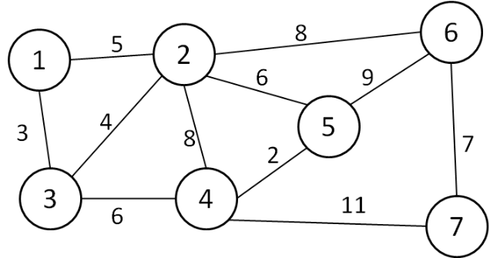 | L3 | CO3 | [7M]
4. | a) | Explain matrix chain multiplication using dynamic programming. | L3 | CO4 | [7M]
 | b) | Solve the following 0/1 knapsack problem by dynamic programming approach. Knap sack with n=4 and m=8. P= {1,2,5,6} W= {2,3,4,5}. | L6 | CO4 | [7M]
5. | a) | Draw and analyze the solution tree for the given Sum of Subsets problem using Backtracking.  n=6, m=30, S={5, 10, 12, 13, 15, 18} | L4 | CO5 | [7M]
 | b) | Derive an algorithm to solve 4-Queens’ problem using Backtracking. | L5 | CO5 | [7M]
6. | a) | Discuss about NP complete Classes. | L6 | CO6 | [7M]
 | b) | Differentiate between NP-Hard and NP-Complete problems. | L5 | CO6 | [7M]
7. | a) | Explain about probabilistic analysis with an example. | L4 | CO1 | [5M]
 | b) | List merits of Divide and Conquer method. | L2 | CO2 | [5M]
 | c) | List the differences between Prim's and Kruskal's algorithms. | L2 | CO3 | [4M]
8. | a) | Write short note on all pairs shortest path problem. | L4 | CO4 | [5M]
 | b) | List the applications of Backtracking method. | L2 | CO5 | [5M]
 | c) | Explain about non-deterministic algorithms. | L2 | CO6 | [4M]

-- 00 -- 00 –

